Interactive Office Planner & Booking System
Challenge Overview
Design a web-based office planning and booking system that helps employees:
- Visualize and interact with their office space
- Book rooms and desks easily
- Discover new ways to collaborate and relax
- Enjoy a personalized and engaging experience
Let your creativity guide the implementation. You decide how features work, how the UI looks, and what tech stack to use.

Core Features (Flexible Implementation)
Interactive Office Layout
- Clickable digital map of the office
- Includes rooms, desks, open spaces, and facilities
- Show availability and user info on hover
- Zoom, pan, and navigate freely

Booking System
- Book rooms, desks, and facilities (massage chairs, pool tables)
- Some bookings may require approval (e.g., large rooms or special events)
- Filter spaces by activity type (e.g., team meeting, relaxation, 1:1s)
- Handle time slots, conflicts, and booking updates

User Accounts
- Users can log in, book spaces, and manage their bookings
- Roles: Employee, Manager/Admin
- Avatar selection or upload
- You decide how authentication works

Creative Features (Flexible Implementation)
- How can the application be made fun?
- How can I, as a user, be more inclined to use the app and not just search for an empty desk the day I come to the office?
- How can our wellbeing spaces (Beer Point and Wellbeing Zone) be used in a creative and interesting way?
- How can the wellbeing facilities help a user?

These are some helping questions, but feel free to let your imagination go wild!
Office spaces:
- Desks for booking

- Offices dedicated to certain people from management

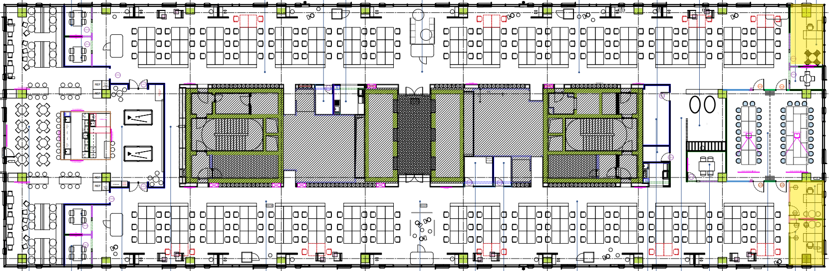

- Small rooms and bubbles for team meetings. All these rooms are named after beers from our worldwide portfolio.

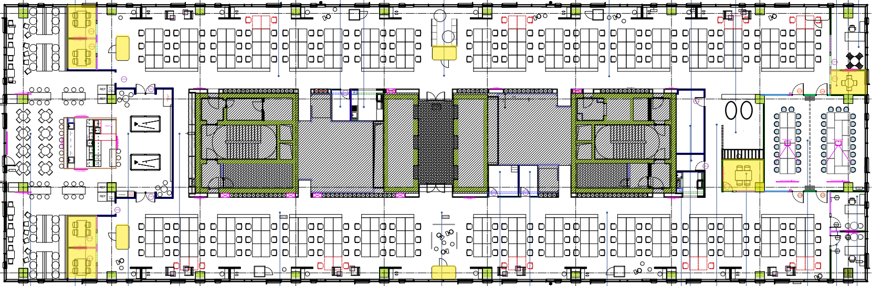

- Two big training rooms (that can be turned into one) for in-person trainings or big team meetings

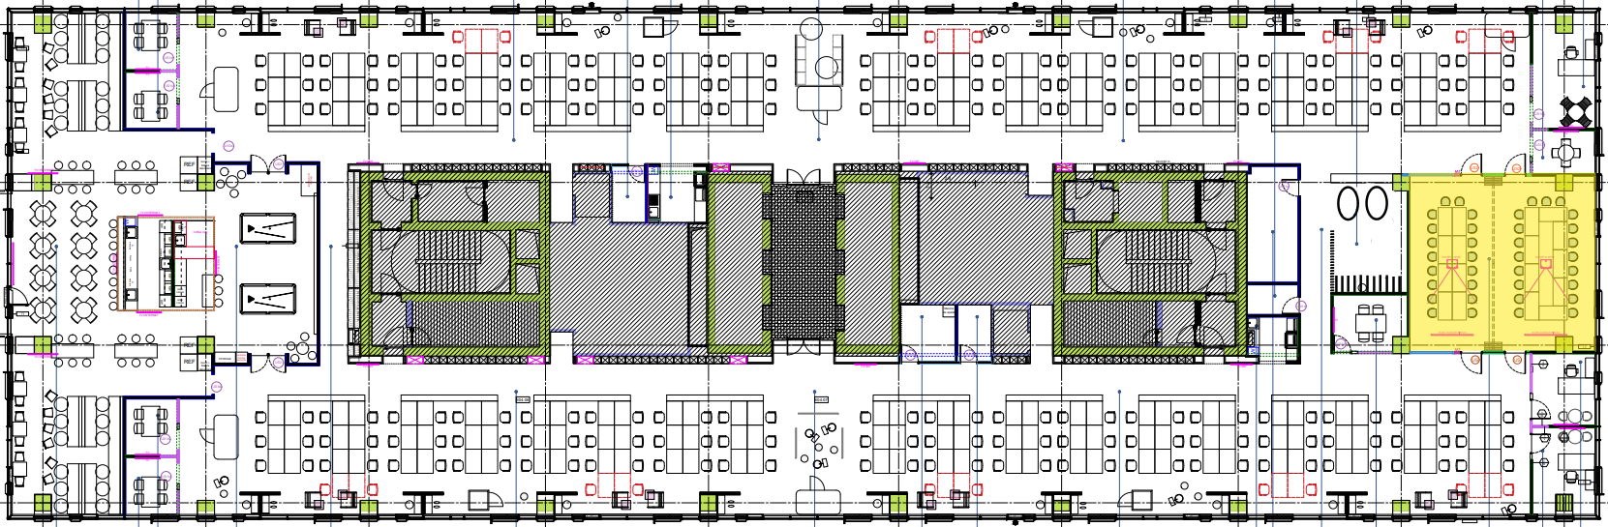

- Beer Point
Dining area with Fresh/beer fridges and pool tables available anytime. However, the room is also used for special events (e.g. team parties, fun workshops)

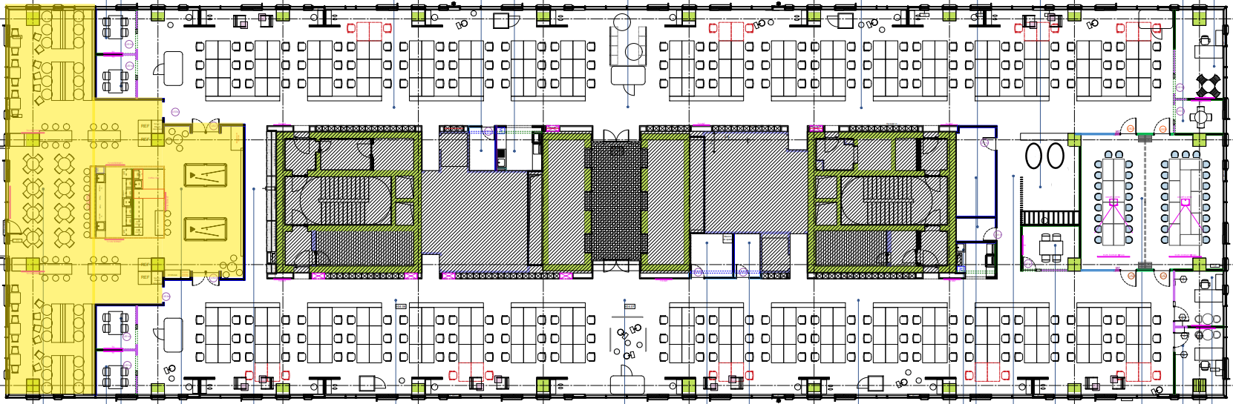

- Wellbeing Zone:
Massage chairs and Bookster area.

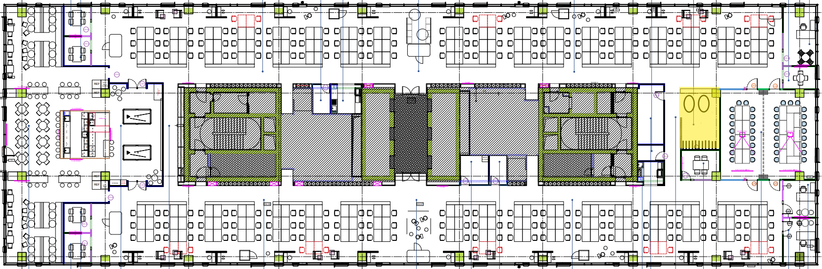

Deliverables
- A functional web app with the features above
- Demo-ready deployment
- README with:
  - Setup instructions
  - Tech stack used
  - Demo credentials (e.g., test@example.com / Hackathon@1234)

